Improve | Innovate | Digitise

Status Draft / Issued

Monday, 2 March 2020

Business Analysis (BAPL)

Benefits Realisation Plan

<<Project Name>>

Document Controls

**Project Information**

|  |  |
| --- | --- |
| Organisation | << Organisation Name >> |
| **Project Sponsor** | << Project Sponsor >> |
| **Project Name** | << Project Name >> |
| **Project Number** | << Project ID >> |

**Contact for Enquires and Proposed Changes**

If you have any questions regarding the information in this document or suggestions for improving the document, please forward details to Business Analysis (BAPL) at the following contact point:

Email: [info@business-analysis.com.au](mailto:info@business-analysis.com.au)

Website: [www.business-analysis.com.au](http://www.business-analysis.com.au)

Phone: 1300 33 11 64

**Version History**

|  |  |  |  |
| --- | --- | --- | --- |
| **Version** | **Date** | **Nature of Amendment** | **Changed By** |
|  |  |  |  |
|  |  |  |  |

**Contributors, Reviewers and Signatories**

The following people were involved in finalising the document:

* Contribute – had input into the creation of the document
* Distribute – receives the document as a courtesy/for information only
* Review – receives the document in order to review and provide feedback
* Endorse – responsible for endorsing/approving the document

| Name & Role | Contribute | Distribute | Review | Endorse |
| --- | --- | --- | --- | --- |
|  |  |  |  |  |
|  |  |  |  |  |
|  |  |  |  |  |

**Stakeholder Review**

The content of this document has been reviewed by:

| Name & Role | Title/Designation | Approval Signature | Date |
| --- | --- | --- | --- |
|  |  |  |  |
|  |  |  |  |
|  |  |  |  |

**Sign-off/Acceptance**

The following people are responsible for signing off on the content of the document. Signatures may be physical, via an email attached to the document or saved in an electronic format and referenced in the table below.

**Signatures constitute an acceptance and agreement of the document’s content.**

| Name & Role | Title/Designation | Approval Signature | Date |
| --- | --- | --- | --- |
|  |  |  |  |
|  |  |  |  |
|  |  |  |  |

**Copyright © Business Analysts Pty Ltd 2012**

Copyright © Business Analysts Pty Ltd 2012. Copyright protects this publication. Except for purposes permitted by the Copyright Act, reproduction by whatever means is prohibited without the prior registration and written permission of Business Analysts Pty Ltd. Inquiries should be addressed to info@business-analysis.com.au. Do not remove this copyright statement.

Copyright © This document has been licensed to <<Organisation Name>>. It must not be copied or reproduced in any way whatsoever outside of <<Organisation Name>> without the authority of Business Analysts Pty Ltd. This document is uncontrolled when printed. An electronic database manages and stores the controlled version.

**Disclaimer**

Business Analysis (BAPL) does not guarantee or warrants the results obtained while using this document and conducting business analysis activities. Usage of this document is strictly under the proviso that the user takes all responsibility for the document outcomes.

Table of Contents

Stakeholder Review III

Sign-off/Acceptance III

1. Executive Summary 1

2. Benefits Management 2

3. Benefits Realisation Plan 3

3.1. Stakeholder Groups 3

3.2. Benefits Summary 3

3.3. Evaluation Plan 4

3.4. Benefits Timeframe 5

3.5. References and Related Documents 5

3.6. Definitions, Acronyms and Abbreviations 5

Appendix A – Benefit Profiles 6

Appendix B – Benefits Realisation Register 7

Appendix C – Payback Period/Cash Flow 8

Table of Figures

Figure 1 – BENEFITS MANAGEMENT 2

Table of Tables

Table 1 - StakeHolder Groups 3

Table 2 – *benefit Name* 3

Table 3 - Evaluation Plan 4

Table 4 - Timeframe 5

Table 5 - References 5

Table 6 - Acronyms 5

Table 7 - Terminology 5

***Template Usage Guidelines***

***The text mentioned below is to be used as a reference guide while completing this document. Remove this section/page after completing/before-publishing this document.***

* *The dark blue text represents help/instructional text in the template – please remove it from the final version and/or before publishing the document.*
* This template is for a Benefits Realisation Plan and should be prepared as a supplementary document to a Functional Specification.
* *Additional sections can be added if required to further document the business requirements. The format for presenting the information can be determined by the author in conjunction with the Practise Lead or client.*
* *Please do not leave any section blank.*
* *Do not forget to update the table of contents figures and caption tables (Reference tab in MSWord) once the document is complete.*

*The Benefits Realisation Plan provides details of how the benefits process will be applied to a program. It describes the tasks, resources, time frame and approach to assessing whether each proposed benefit has been achieved.*

***Step One***

* Complete a Benefit Profile for each benefit (Appendix A)
* Remember to measure impacts across all relevant stakeholder groups.

1. Executive Summary

The Benefits Realisation Plan provides details of how the benefits process will be applied to a program. It describes the tasks, resources, time frame and approach. The executive summary is a brief overview of the program, key benefits and how they will be measured and tracked.

1. Benefits Management

Benefits Management is the process of identifying, structuring, planning, executing, reviewing and evaluating benefits.

Figure 1 – BENEFITS MANAGEMENT

**Identify**

**& Structure**

**Benefits**

**Plan**

**Benefits**

**Realisation**

**Potential**

**for Further**

**Benefits**

**Review &**

**Evaluate**

**Results**

**Execute**

**Benefits**

**Plan**

Delivering benefits is the primary reason why organisations undertake change. A benefit must be both positive and measurable. Negative impacts relating to change may also be identified, but these are usually acceptable in the context of project. Disbenefits should be captured in the project issue log where then have not been previously documented in the Change Management plan.

Forming the basis of the Business Case the forecast benefits of project may be quantitative (EFT reductions, productivity or financial savings) or qualitative (work-life balance, employee satisfaction). They may, or may not, also be quantifiable in financial terms.

Most projects will contain a combination of quantitative and qualitative benefits, with a higher weighting of quantitative benefits. Regardless of the type of benefit all must be assessed utilising quantitative methods.

Benefits will require proactive monitoring throughout the project life cycle. During the change, the organisation needs to monitor evaluation measures indicators to assess benefits delivery.

Additionally, close monitoring of the change process may identify new opportunities to further improve business processes.

The goal of this document is to document the mechanisms, timelines and persons responsible for measuring the realisation of the strategic benefits anticipated in the Business Case.

1. Benefits Realisation Plan
   1. Stakeholder Groups

The benefits specified need be assessed from several perspectives, as each group of stakeholders may require different assessment measures. The following user groups will be assessed as to the realisation of the strategic benefits.

Table 1 - StakeHolder Groups

|  |  |
| --- | --- |
| Group Name | Bustiness Activity |
| *Customer* |  |
| *Reception staff* |  |
| *Managers* |  |

* 1. Benefits Summary

*All benefits and outcomes specified in the Business Case should be specified in the following section.*

*Provide details of the expected benefits the initiative will deliver based on the recommended option. These must be expressed in measurable terms against today’s situation. Benefits may include:*

*Direct Financial Benefit*

* + *Additional revenue generated as a result of the project*
  + *Direct Cost savings as a result of the project*

*Indirect Financial Benefit*

* + *This may be opportunity benefits that could be linked to the improvement*

*Non-Financial Benefit*

* + *Social*
  + *Economic*
  + *Environmental*

The following benefits have been identified as a result of implementing the *name of project* (Please see Appendix A: Benefit Profiles for additional details).

Table 2 – *benefit Name*

|  |  |  |  |  |  |  |
| --- | --- | --- | --- | --- | --- | --- |
| ID | Benefit Name | Benefit Description | Benefit Type | Benefit Classification | Benefit Owner | Associated Requirement/Epic |
| *ID* | *Short name* | *Long description* | *Financial or non-financial* | *Increased revenue, reduced cost, improved performance* | *Business person responsible for the realisation of the benefit (sponsor)* | *Specify requirement ID and requirement statement / name of the Epic* |
| **Baseline** | | | | | | |
| *Describe how this benefit has been baselined. Baseline measurements identify the current so that improvements can be measured.* | | | | | | |
| **Is the measure currently monitored? How?** | | | | | | |
| *Existing mechanisms may exist that can be utilised to measure the benefit. Please specify.* | | | | | | |
| **Strategic Alignment** | | | | | | |
| *Organisational goal or strategic value to which the benefit aligns.* | | | | | | |

*Create a new table for each benefit.*

* 1. Evaluation Plan

*The benefits associated with strategic organisational change are delivered through programmes of multiple-aligned projects and change management activity. Such programmes can contain complex interactions between the outputs of individual projects, outcomes and benefits. It may be the case that multiple projects have an impact on the same benefits. It is important just to measure and acknowledge the change has happened (or not) – attributing the cause of this can come later.*

* *Make sure that you have measurable deliverables. If you can’t find a baseline, how are you going to measure them at the end?*
* *The benefits derived from each of these deliverables needs to be assessed from several perspectives, as what may be a benefit to one group of stakeholders may be a dis-benefit to others or no benefit. Create separate benefit tables if the perspectives of relevant groups differ.*
* *Think about breaking down big, difficult-to-measure benefits into smaller ones. This way you might be able to measure several smaller benefits that all feed into the bigger overall benefit.*
* *Don’t assign the benefit ownership to the Project Manager – benefits may not be realised until after the official close of the project and it is important that someone is responsible for measuring these.*
* *It is safe to assume that measurement will be completed most accurately by those who have an interest in the results, and who have benefited from the project themselves. Key stakeholders, programme executives and Senior Users are all valuable as benefit owners.*
* *Start measuring benefits early after delivery.*
* *Remember – the benefit owners do not have to collect the measurement data themselves; they are just responsible for ensuring that their benefit is measured and is signed off once realised.*

The plan below uses the benefits outlined in the original Business Case and identifies measurements that will enable assessment as to whether specific benefit has been derived.

This section documents how each how each benefit will be measured against impacted stakeholder groups (See Appendix for additional detail).

For the purposes of *<< Project Name >>* benefits will be collected*…describe timeframe, model and key mechanisms to be utilised.*

It should be noted that any unanticipated benefits or disbenefits should also be documented during the measurement process for further analysis.

Table 3 - Evaluation Plan

|  |  |  |  |  |  |
| --- | --- | --- | --- | --- | --- |
| ID | Benefit Name | Stakeholder Group | Date | Measurement Method | Person Responsible |
| *B01* | *Workforce costs reduced* | *Finance* | *End of FY* | *Workforce Financial Report*  *Reduced cost of induction training* | *Director of Finance* |
|  |  |  |  |  |  |

*Repeat for each stakeholder group. Ensure all benefits are included*

* 1. Benefits Timeframe

*Provide a high-level project timeframe for all benefit assessment activities.*

Table 4 - Timeframe

|  |  |  |  |  |
| --- | --- | --- | --- | --- |
| Estimated Date | Activity type | Benefit ID | Benefit Name | Stakeholder Group |
|  | *Baseline* |  |  | *Customer* |
|  | *Evaluation* |  |  | *Reception staff* |
|  |  |  |  | *Managers* |

* 1. References and Related Documents

*List any other documents that support this Business Case including pre-project documents like Concept Briefs feasibility analysis, the Project Plan and Benefits Plan; strategy documents, change control, risks and issues (including the Risk Register), stakeholders and communications and project quality.*

Table of references and related documents used within this document are contained in the following table.

Table 5 - References

|  |  |  |
| --- | --- | --- |
| Document Type | Document Name | Location |
| *Business Case* |  | *Link here* |

* 1. Definitions, Acronyms and Abbreviations

Table of terms and associated descriptions used within this document are contained in the following table.

Table 6 - Acronyms

|  |  |
| --- | --- |
| Acronym | Definition |
|  |  |

Table 7 - Terminology

|  |  |
| --- | --- |
| Terminology | Definition |
| *Business Case Initiative* | *The project to deliver the recommendation of the business case and the operation of the resulting outputs of the project over its lifetime.* |

Appendix A – Benefit Profiles

*Complete a benefit profile for each benefit.*

|  |  |  |  |  |  |  |  |  |
| --- | --- | --- | --- | --- | --- | --- | --- | --- |
| **Benefit Profile** | | | | | | | | |
| **Project Name:** | | |  | | | | | |
| **Stakeholder Groups:** | | | *List stakeholder groups benefitted* | | | | | |
| **Benefit ID:** |  | | **Benefit Name:** | |  | | | |
| **Benefit Description:** | | | *Describe the issue the project is addressing* | | | | | |
| **Benefit Type:** | | | *Financial or non-financial* | | | | | |
| **Benefit Classification:** | | | *Increased revenue, reduced cost, improved performance etc* | | | | | |
| **Strategic Alignment:** | | | *Specify organisational goal or strategic value to which the benefit aligns.* | | | | | |
| **Risks/issues:** | | | *Track risks and issues (high-level) to demonstrate they have been considered* | | | | | |
| **Benefit Owner:** | | | *Business person responsible for the realisation of the benefit (sponsor)* | | | | | |
| **Associated requirement/Epic:** | | | *Requirement ID, requirement statement / Epic name* | | | | | |
| **Measures** | | | | | | | | |
| **Stakeholder Group** | | *Describe stakeholder/stakeholder group/s to which this measure will relate* | | | | | | |
| **Measurement Description** | | *Describe measurement mechanisms* | | | | | | |
| **Start date:** | | *DD/MM/20YY* | | **End date: DD/MM/20YY** | | *DD/MM/20YY* | **Data source:** | *Where will the data come from?* |
| **Owner:** | | *Person responsible for collating the measure* | | **Review frequency:** | |  | **Measure currently monitored:** | *Yes/No, How?* |
| **Baseline value:** | |  | | **Goal value:** | |  | **Benefit calculation method:** |  |

*May be multiple measures utilised. Complete a separate Measure table for each method and stakeholder group if the measurement mechanism differs.*

Appendix B – Benefits Realisation Register

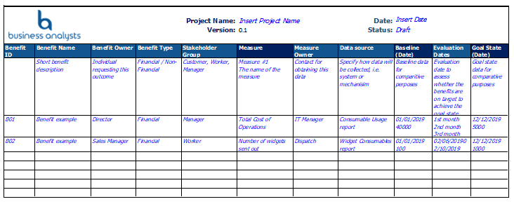

Appendix C – *Payback Period/Cash Flow*

*Add appendices if they assist in demonstrating benefits.*

*i.e. The Cumulative Cash flow diagram below indicates the point at which Option X will pay back the invested amount, and the trajectory from that point. As you can see …..*

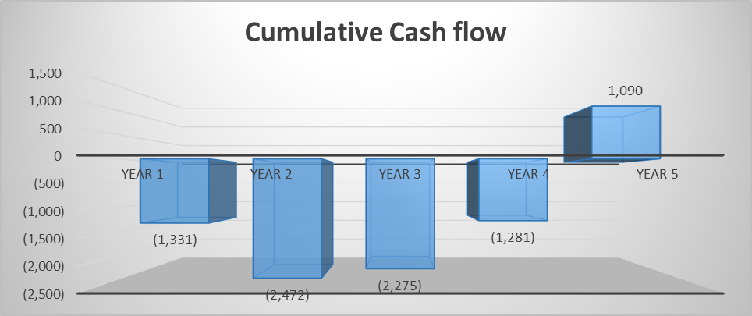

*The* *Cash Flow chart below assesses the difference between the cash flow generated from the current state (do nothing option) and the preferred option. As can be seen, the preferred option begins to provide a greater cash flow to the business within 3 years of implementation. This trajectory increases to over a 100% improvement by year 5.*