Improve | Innovate | Digitise

Improve | Innovate | Digitise

Solution Requirements Specification
<<Project Name>>
Status Draft / Issued
Monday, 2 March 2020
Business Analysts Pty Ltd

Document Controls

Project Information
Organisation | << Organisation Name >>
Project Sponsor | << Project Sponsor >>
Project Name | << Project Name >>
Project Number | << Project ID >>

Contact for Enquires and Proposed Changes
If you have any questions regarding the information in this document or suggestions for improving the document, , please forward details to Business Analysis (BAPL) at the following contact point:
Email: info@business-analysis.com.au
Website: www.business-analysis.com.au
Phone: 1300 33 11 64

Version History
Version | Date | Nature of Amendment | Changed By

Contributors, Reviewers and Signatories
The following people were involved in finalising the document:
- Contribute – had input into the creation of the document
- Distribute – receives the document as a courtesy/for information only
- Review – receives the document in order to review and provide feedback
- Endorse – responsible for endorsing/approving the document

Name & Role | Contribute | Distribute | Review | Endorse

Stakeholder Review
The content of this document has been reviewed by:

Name & Role | Title/Designation | Approval Signature | Date

Sign-off/Acceptance
The following people are responsible for signing off on the content of the document. Signatures may be physical, via an email attached to the document or saved in an electronic format and referenced in the table below.

Signatures constitute an acceptance and agreement of the document’s content.

Name & Role | Title/Designation | Approval Signature | Date

Copyright © Business Analysts Pty Ltd 2012
Copyright © Business Analysts Pty Ltd 2012. Copyright protects this publication. Except for purposes permitted by the Copyright Act, reproduction by whatever means is prohibited without the prior registration and written permission of Business Analysts Pty Ltd. Inquiries should be addressed to info@business-analysis.com.au. Do not remove this copyright statement.
Copyright © This document has been licensed to <<Organisation Name>>. It must not be copied or reproduced in any way whatsoever outside of <<Organisation Name>> without the authority of Business Analysts Pty Ltd. This document is uncontrolled when printed. An electronic database manages and stores the controlled version.

Disclaimer
Business Analysis (BAPL) does not guarantee or warrants the results obtained while using this document and conducting business analysis activities. Usage of this document is strictly under the proviso that the user takes all responsibility for the document outcomes.

Table of Contents
Document Controls II
Stakeholder Review III
Sign-off/Acceptance III
1. Executive Summary 2
2. Introduction 3
2.1. Purpose 3
2.2. Definitions, Acronyms and Abbreviations 3
2.3. References and Related Documents 3
2.4. Business Context 3
2.5. Anticipated Business Benefits/Outcomes 3
2.6. Stakeholders and End Users 3
2.7. Scope 4
2.7.1. Inclusions 4
2.7.2. Exclusions 4
2.8. Assumptions 4
2.9. Constraints 4
2.10. Dependencies 5
2.11. Risks and Issues 5
2.12. Requirements Framework 6
3. Use Case Model 7
3.1. Actors 7
3.2. Use Case Diagram 7
3.3. Use Case Descriptions 7
3.4. Use Cases for Project Name 7
3.4.1. UC01 – Use Case Name 7
3.4.1.1. UC01 – Functional Requirements 8
3.4.2. UC02 – Access Service Contract 9
3.4.2.1. UC02 – Functional Requirements 10
4. Interface requirements 11
4.1. User Interface Requirements 11
4.2. System Interface Requirements 11
4.2.1. System Interface Name Diagram 11
4.2.2. System Interface Name Description 11
4.2.3. System Interface Name Requirements 11
4.3. Hardware Interface Requirements (if applicable) 12
5. Information Requirements 13
5.1. Information Model 13
5.2. Information Requirements 13
5.2.1. Information Model Element1 Requirements 13
5.2.2. Information Model Element2 Requirements 13
6. Quality of Service (Non-Functional Requirements) 14
6.1. Performance 14
6.2. Availability / Reliability 14
6.3. Unavailability Impact 15
6.4. Security / Access 15
6.5. Scalability 15
6.6. Usability 16
6.7. Portability 16
6.8. Maintainability / Supportability 16
6.9. Licensing 16
7. Appendix A – 17

Table of Figures
Figure 1- System Interface Name Diagram 11
Figure 2- Class Diagram 13

Table of Tables
Table 1- Acronyms 4
Table 2 - References 4
Table 3– Stakeholders and end users 5
Table 4 – constraints 5
Table 5 - DependEncies 6
Table 6 – risks and issues 6
Table 7 - Actors 7
Table 8 - Use Case Descriptions 7
Table 9 - UC01 - FUNCTIONAL REQUIREMENTS 7
Table 10 - UC0X - Functional Requirements 8
Table 11- UC02 - FUNCTIONAL REQUIREMENTS 9
Table 12 - UC02 - Functional Requirements 10
Table 13 - User Interface Requirements 11
Table 14 - System Interface Requirements 11
Table 15- Hardware Interface Requirements 12
Table 16 - Information Model 1 Requirements 13
Table 17 - Information Model 2 Requirements 13
Table 18 - Quality of Service - Performance 14
Table 19 - Quality Of Service - Availibility / Reliability 14
Table 20 - Service Of Quality - Unavailibility Impact 15
Table 21 - Quality Of Service - Security / Access 15
Table 22 - Quality Of Service - Scalibility 15
Table 23 - Quality Of Service - Usability 16
Table 24 - Quality Of Service - Portability 16
Table 25 - Quality Of Service - Maintainability / Supportability 16
Table 26- Quality Of Service - Licensing 16

Template Usage Guidelines

The text mentioned below is to be used as a reference guide while completing this document. Remove this section/page after completing/before-publishing this document.
- The dark blue text represents help/instructional text in the template – please remove it from the final version and/or before publishing the document.
- This template is designed to capture Functional and Non-functional requirements. If high level stakeholder requirements (ie for an RFI) then these should be recorded in the BAPL Business Requirements Specification template.
- Additional sections can be added if required to further document the business requirements. The format for presenting the information can be determined by the author in conjunction with the Practise Lead.

- Please do not remove any section(s) from this document unless otherwise specified.
- Please do not leave any section blank.
- Please ensure not to describe any System Design element(s) in this document.
- Do not forget to update the table of contents figures and caption tables (Reference tab in MSWord) once the document is complete.
- Introduce naming conventions as required for traceability purposes.
Naming Standards/Terminology
Requirement Category | Naming Standard/Terminology
Functional Requirement | FR
Non-Functional Requirements | NR- <first 2/3 alphabets if the requirement category is defined by a single word e.g. ‘PE’ for ‘Performance’, ‘LIC’ for Licensing>  OR  NR- <first alphabet of each word if the requirement category is defined by more than one word e.g. for ‘Word1 Word2’ use WW>  In either case, ensure there is no duplication within the Non-Functional Requirement naming standards/terminology.

Other Naming Standards/Terminology
Item Category | Naming Standard/Terminology | Examples
Business Rule | BR <Integer/Number> | BR1, BR25, BR50
Use Case | UC <Integer/Number> | UC10, UC15, UC25
Use Case Diagram | UCD <Integer/Number> | UCD1, UCD5
Context Diagram | CD <Integer/Number> | CD2, CD5
Sequence Diagram | SD <Integer/Number> | SD10, SD15
Work Flow Diagram | WFD <Integer/Number> | WFD5, WFD7
Data Flow Diagram | DFD <Integer/Number> | DFD3, DFD10
Data Dictionary | DD <Integer/Number> | DD3, DD7, DD10
- Executive Summary
Executive summaries should be written in plain English, avoiding technical language where possible.
- Provide a description and information about the current business need. State the Business need/problem explicitly. What is the impact of this problem on the business?
- Describe the current state, how the business currently operates, and any problems or enhancements that will be addressed by the project.
- Describe who the audience the of the document is and the teams impacted– include details such as team names/roles, if known, and their involvement in the current processes. Organisational/Business Services structure can also be included where appropriate.
For example:
Operators within the Admin Processing Team are required to manually manipulate reports daily, which takes between 1 and 2 hours.
- Outline the systems involved in the current business processes. Include system names and the specifics of their involvement with this project.
- Reveal any documentation in which this document should be read in conjunction, such a Vision documents, Business process model documents etc.
- Make a scope statement, including what is in and out of scope

- Introduction
  - Purpose
The purpose of this document is to
Describe the purpose of this document within the context of the project.
i.e. The purpose of this document is to describe the current “as is” and future “to be” business processes and business requirements involved in the management of << Project Name >>.
This document will be used to identify business processes for potential automation, evaluate existing automated processes for improvement where appropriate and used as a basis for business requirements for new information solutions.

  - Definitions, Acronyms and Abbreviations
The acronyms, abbreviations and terms used within this document are defined in the following table.
Table 1- Acronyms
Acronyms | Definition

  - References and Related Documents
The references and related documents used within this document are contained in the following table.
Table 2 - References
Document Name | Document Type | Location
Attach relevant documents as an appendix.

  - Business Context
Describe the business problem or opportunity
Provide a description and information about the current business need. State the Business need/problem explicitly. What is the impact of this problem on the business?

  - Anticipated Business Benefits/Outcomes
Briefly state the expected end state benefits/outcomes that the Business wants to achieve through this project. Please ensure that the benefits mentioned in this section are a mix of both high level benefits and low level benefits. The benefits can include both qualitative and quantitative items.
As a rule of thumb, the anticipated benefits must be linked with the stated Business Goal/Objective.

  - Stakeholders and End Users
Stakeholders are the individuals or groups who have a vested interest in this project and whose interests need to be considered throughout the project. This section lists the Stakeholders of the Application/Project for which these Business requirements have been documented.
Identify the primary/key stakeholders impacted by the project. This can include business users, end users, sponsors, project team, other users indirectly impacted etc; also include a stakeholder map.

The following Stakeholders and End Users have been identified:
Table 3– Stakeholders and end users
Stakeholder | Area of Business Impact
List the stakeholder | Briefly mention the business area impacted

  - Scope
    - Inclusions
Describe the intended scope of the project or initiative.
The following Inclusions have been identified:
- Inclusion # 1
- Inclusion # 2
- Inclusion # 3

    - Exclusions
Detail what is not in scope and what opportunities have been intentionally not pursued for this project or initiative.
Exclusion are specified as follows:
- Exclusion # 1
- Exclusion # 2
- Exclusion # 3

  - Assumptions
Clearly detail all assumptions in relation to this document.
For example – It is assumed that ABC will continue to be the external provider of service XYZ.
The following Assumptions have been identified:
- Assumption # 1
- Assumption # 2
- Assumption # 3

  - Constraints
- List the constraints that have been identified.
The following constraints have been identified:
Table 4 – constraints
Constraint Name | Description | Constraint Type | Constraint Handler
List the constraint name | Add a brief description of the constraint | Indicate the constraint type as in for e.g. Regulatory, Statutory, Data Privacy, Code of Conduct etc. | Mention the required action; e.g. Abide with the constraint, provide solution, work around etc.

  - Dependencies
List the Requirement dependencies that have been identified. These could be dependencies on other projects, resources, people or business areas/functions.
The following dependencies have been identified:
Table 5 - DEPENDENCIES
Dependency | Description | Dependency Type | Coordination Approach
List the dependency name | Add a brief description of the dependency | Are we dependent on other projects/ resources/ business functions?  OR  Are they dependent on us?  Or  Both? | What measures are in place to manage the dependency?

  - Risks and Issues
List any risks / issues that have been identified and are being actively managed. Include high-level risks and issues rather than smaller day-to-day ones. All Project level risks & issues will be managed separately as part of the Project Risk Register by the Project Manager.
The following requirement level risks/issues have been identified and will need to be managed to ensure the project requirements are successfully delivered:
Table 6 – risks and issues
Risk / Issue | Likelihood / Impact | Mitigation Approach
List the risk/issue name | What is the likelihood it will occur? If it does occur, how significant is the impact? | What mitigation approach will be used to manage the risk/issue?

  - Requirements Framework
Describe the approach to requirements including the various requirements categories (business, stakeholder, solution, etc. that are covered in this document)
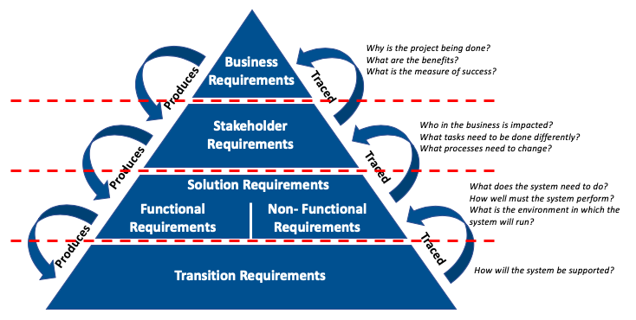
- Use Case Model
  - Actors
The names of the actors and a description of their roles are listed in the following table.
Table 7 - Actors
Actor Name | Description | Alias
Role name | Description of the role in relation to the way it interacts with the system | List any other business names that are used to refer to this role

  - Use Case Diagram
The following diagram depicts the use cases described in this document.
Insert Use Case diagram

  - Use Case Descriptions
The following table provides a summary of each of the use cases shown in the use case diagram.
Table 8 - Use Case Descriptions
UC Id / Name | UC Description
Use Case Id and name | The goal and description of the use case

  - Use Cases for Project Name
Define the steps associated with performing the illustrated business activity/use case for Use Cases listed in the previous section. (Include alternative and exception flows).
If there are numerous Use Cases/Descriptions, it may be appropriate to include them in the Appendix rather than in the body of the document.
In general, user stories are more commonly used within agile methodology, while requirements documents are more commonly associated with the traditional waterfall methodology. Agile teams tend to use user stories more often than requirements as they allow flexibility and collaboration, whereas waterfall teams use requirements and requirements docs to specify the finer details prior to commencing development.
User cases serve their purpose well when their syntax describes the “required” functionality from the system in response to the user interaction, without specifying the details of “how” to execute this functionality.

    - UC01 – Use Case Name
Table 9 - UC01 - FUNCTIONAL REQUIREMENTS
UC01 | Use Case Name
Goal/description
Actors | Anyone or anything that performs a behaviour (who is using the system)
Triggers | The event that causes the use case to be initiated
System
Pre-condition 1 | What must be true or happen before the use case runs
Pre-condition 2
Post-conditions | What must be true or happen after the use case is complete
Normal Flow
Description | Describe the basic course in the description for the use case
1
2
Termination outcome
Alternative flow XA: Description
Description | Result positive: An Alternate Flow is a step or a sequence of steps that achieves the use case’s goal following different steps than described in the main success scenario. But the goal is finally achieved
4A1
4A2
Termination outcome
Exception Flow XB: Description
Description | Result negative: An Exception is anything that leads to NOT achieving the use case’s goal
4A1
4A2
Termination outcome
Business Rules:
UC1BR1

      - UC01 – Functional Requirements
Using the style specified in the help text of the previous section, every use case line that states “system does …< something>”, is a function that the system is expected to perform and therefore can be a potential Functional Specification.
Table 10 - UC01 - Functional Requirements
Id | Requirement Description | Process Reference
FRUC00x | Functional requirement | Process Activity Name
FRUC00y | Functional requirement | Process Activity Name
Repeat fully dressed structure for each Use Case

    - UC02 – Access Service Contract
Example
Table 11- UC02 - FUNCTIONAL REQUIREMENTS
UC1 | User accesses a contract saved in the Service Contract Record System (SCoRS)
The purpose of this use case is to allow Service Contract records information to be accessed by the registered users
Actors | Registered Users, Unregistered User | Service Contract Record System (SCoRS)
Triggers | User seeks to access a contract saved in the Service Contract Record System (SCoRS)
System | Service Contract Record System (SCoRS)
Pre-condition 1 | Service Contract User must have access to Service Contract Record System portal.
Pre-condition 2 | A Service Contract Record exists and the User seeks to access the saved version of the record.
Post-conditions | Service Contract will be unlocked while being accessed by registered User. They will remain locked to other users until the Service Contract User ‘checks’ the Contract ‘back in’.
Normal Flow
Description | User seeks access to a Service Contract saved in SCoRS
1 | User attempts to log on to SCoRS
2 | Inclusion, perform Verify Security Permission Use Case. SCoRS verifies User’s security access, permissions etc.
3 | User specifies the Service Contract record identifier in SCoRS
4 | Service Contract record is made available for the User to view
5 | If the User wants to update the Service Contract record, extension,  perform Update Service Contract record use case
6 | If the User wants to access additional records, go to step 3
Termination outcome | User checks Service Contract record back in and exits SCoRS
Alternative Flow 4A: Service Contract record not found
Description | SCoRS does not recognise the User as having the correct permissions to review Service Contract records
4A1 | No Service Contract records are made available for the User to view
4A2 | SCoRS alerts the User that there are no Service Contract records matching that description. Recheck details and try again
Termination outcome | SCoRS returns to step 3 in the normal flow
Exception Flow 2A: SCoRS does not recognize User as having access to the system
Description | SCoRS does not recognize the User’s security credentials
2A1 | If verification of the User’s identification has failed three times, SCoRS will disable this data entry interface. SCoRS logs these attempts in the security log
2A2 | If verification of the User’s identification has not yet failed three times, SCoRS asks the User to re-enter identification.
2A3 | SCoRS repeats step 2 the normal flow
Termination outcome | If verification of the User’s identification has failed three times, this use case then terminates
Exception Flow 2B: SCoRS does not recognize the User as having permission to view Service Contract records
Description | SCoRS does not recognise the User as having the correct permissions to review Service Contract records
2B1 | User is denied access to Service Contract records
2B2 | SCoRS alerts the User that they do not have sufficient permission to view Service Contract records
Termination outcome | SCoRS returns to step 1 in the normal flow
Business Rules:
UC1BR1 | User must be registered to access SCoRS
UC1BR2 | User must know personal security credentials

      - UC02 – Functional Requirements
Table 12 - UC02 - Functional Requirements
Id | Requirement Description | Process Reference
FRUC001 | The system must verify that the User is registered | Normal Flow, 2
FRUC002 | The system must allow the User three attempts to enter the correct user credentials before exiting the logon screen | Exception Flow, 2A2
FRUC003 | The system must display informational alerts when a User has entered incorrect security credentials | Exception Flow, 4A2
FRUC004 | The system must verify that the User has the appropriate permissions to access records | Exception Flow, 2B1
FRUC005 | The system must display informational alerts when a User has conducted an invalid query and no records are found | Alternate Flow, 4A2
FRUC006 | The system must display the correct Service Contract record when selected by the User | Normal Flow, 4

- Interface requirements
  - User Interface Requirements
Insert GUI user interface requirements
Table 13 - User Interface Requirements
Id | Requirement Description
FRUIGUI001 | Functional requirement
FRUIGUI002 | Functional requirement

  - System Interface Requirements
    - System Interface Name Diagram
Insert system interface diagram
Figure 1- System Interface Name Diagram
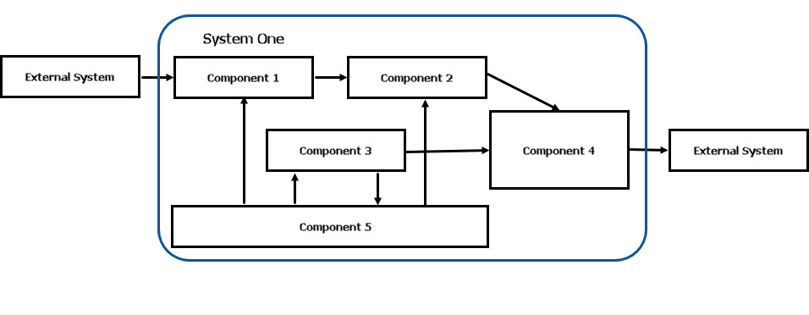

    - System Interface Name Description
Insert system interface descriptions
Interface Design Description (IDD) describes the interface characteristics of one or more systems, subsystems, Hardware Configuration Items, Computer Software Configuration Items, manual operations, or other system components. An IDD may describe any number of interfaces.

    - System Interface Name Requirements
Interface Requirements serve to communicate and control interface design decisions. These are the “shall” statements that drive the design.
Table 14 - System Interface Requirements
Id | Requirement
FRSIR???

  - Hardware Interface Requirements (if applicable)
Insert hardware interface requirements
Hardware interface requirements describe the architecture used to interconnect two devices together. It includes the design of the plug and socket, the type, number and purpose of the wires and the electrical signals that are passed across them, standards and regulations.
Table 15- Hardware Interface Requirements
Id | Requirement
FRHIR???

- Information Requirements
  - Information Model
Insert class diagram
Figure 2- Class Diagram
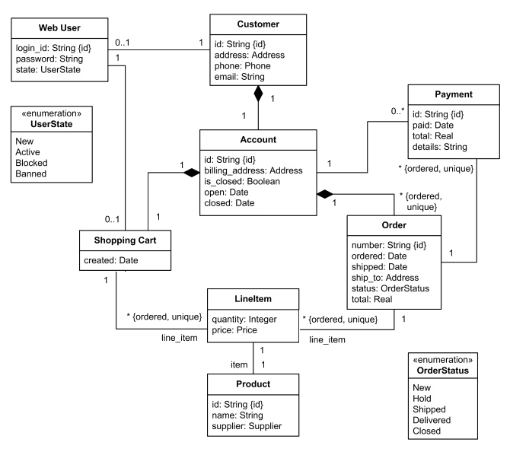
  - Information Requirements
The entity types in the model may be real-world objects, such as devices in a network, or occurrences, or abstract, such as for the entities used in a billing system.
    - Information Model Element1 Requirements
Table 16 - Information Model 1 Requirements
Id | Requirement
FRIME???

    - Information Model Element2 Requirements
Table 17 - Information Model 2 Requirements
Id | Requirement
Repeat for all Information Model Elements
- Quality of Service (Non-Functional Requirements)
  - Performance
System performance across all components of the solution is to be documented, considering but not limited to the following:
Number of business users will use the system concurrently
Speed of system functions (User Interface vs Back-end Functions)
Identify high performance areas, which may relate to core business processes
Variations to performance due to location (e.g. remote/wireless access)
Table 18 - Quality of Service - Performance
ID | Solution Component | Service Level Agreement (SLA) Target
NFR??? | Application – UI internal | Performance metric: <<>>  Business Hours: <<>>  Peak/Maximum: <<>>  After Hours: <<>>
 | Application – UI external & customers | Performance metric: <<>>  Business Hours: <<>>  Peak/Maximum: <<>>  After Hours: <<>>
 | Application - Reports | Performance metric: <<>>
 | Application – Back-end | Performance metric: <<>>
 | Infrastructure | Performance metric: <<>>  Storage Capacity: <<>>  Connections (Concurrent): <<>>  External Access: <<>>
 | Network - Central | Performance metric: <<>>
 | Network – Remote | Performance metric: <<>>
 | Network – Wireless | Performance metric: <<>>

  - Availability / Reliability
Insert availability and reliability requirements, indicating usage during business hours and users expected during peak and off peak times
Table 19 - Quality Of Service - Availibility / Reliability
Id | Solution Component | Service Level Agreement (SLA) Target
NFR??? | Application – Business Hours | <<>>%
 | Application – After Hours | <<>>%
 | Infrastructure | <<>>%
 | Network | <<>>%
 | Disaster Recovery | Timeframe for recovery

  - Unavailability Impact
Describe the impact to business of the system being unavailable; assess impacts in terms of unavailability over timeframes to specific user groups. Impact may include, immediate risks, delayed risks, and mitigation of risks, such as manual workaround, delays, contacting customers, loss of custom, reputational loss, advantage to competitors
Table 20 - Service Of Quality - Unavailibility Impact
Id | Business Unit / Role | Impact
NFR??? | Data Operator | 1-4 hours: <<>>  4-8 hours: <<>>  1 Day: <<>>  2 Days: <<>>  3 Days: <<>>
 | Management | <<>>
 | Finance | <<>>
 | Human Resources | <<>>
 | Customers | <<>>

  - Security / Access
Table 21 - Quality Of Service - Security / Access
Id | Business Unit / Role | Impact
NFR??? | Internal Access (Staff): | logins, certificates, security codes
 | External Access (Staff): | logins, certificates, security codes
 | Partner Access: | logins, certificates, security codes
 | Client/Customer Access: | logins, certificates, security codes
 | Internal Access (Staff): | logins, certificates, security codes

  - Scalability
What is the predicted business growth over the next five years?
What are the number of system users and user growth over next 5 years?
Is there location specific growth predicted?
Table 22 - Quality Of Service - Scalibility
Id | Requirement | Description / Additional Details

  - Usability
Are there any special usability requirements?
Consider business scenarios that would test system usability
Table 23 - Quality Of Service - Usability
Id | Requirement | Description / Additional Details

  - Portability
Are there business advantages to delivering the system at the location of data capturing? What are the portability requirements?
Table 24 - Quality Of Service - Portability
Id | Requirement | Description / Additional Details

  - Maintainability / Supportability
What is the most suitable day and time for the business for support and changes to the system
Are there scheduled maintenance windows?
Table 25 - Quality Of Service - Maintainability / Supportability
Id | Requirement | Description / Additional Details

  - Licensing
How many licences are required for the system?
Are there different levels of licence?
Table 26- Quality Of Service - Licensing
Id | Requirement | Description / Additional Details

- Appendix A –
Consider consolidating all requirements and putting them in a Requirement Traceability Matrix (RTM).
Use appendices for extended detail, often supplied by the stakeholder as supplementary materials, such as:
• Document References
• Use Cases and Use Diagrams
• Process Models
• Business Level Process Models
• System Level Process Models
• Business Architecture
• Application Architecture
• Technical Architecture
• Data Requirements
• Conceptual Data Model
• Data Flow Diagrams
• Data Migration Needs
• Data Conversion/Cleansing Needs
• Data Volumes
• Data Backup/Retention and Archiving Needs
• Data Privacy Implications
• Data Dictionary
• Integration Requirements
• Integration with other Systems

