Improve | Innovate | Digitise

Status Draft

Monday, 2 March 2020

Business Analysis (BAPL)

Business Case

<<Project Name>>

Document Controls

**Project Information**

|  |  |
| --- | --- |
| Organisation | << Organisation Name >> |
| **Project Sponsor** | << Project Sponsor >> |
| **Project Name** | << Project Name >> |
| **Project Number** | << Project ID >> |

**Contact for Enquires and Proposed Changes**

If you have any questions regarding the information in this document or suggestions for improving the document, please forward details to Business Analysis (BAPL) at the following contact point:

Email: [info@business-analysis.com.au](mailto:info@business-analysis.com.au)

Website: [www.business-analysis.com.au](http://www.business-analysis.com.au)

Phone: 1300 33 11 64

**Version History**

|  |  |  |  |
| --- | --- | --- | --- |
| **Version** | **Date** | **Nature of Amendment** | **Changed By** |
|  |  |  |  |
|  |  |  |  |

**Contributors, Reviewers and Signatories**

The following people were involved in finalising the document:

* Contribute – had input into the creation of the document
* Distribute – receives the document as a courtesy/for information only
* Review – receives the document in order to review and provide feedback
* Endorse – responsible for endorsing/approving the document

| Name & Role | Contribute | Distribute | Review | Endorse |
| --- | --- | --- | --- | --- |
|  |  |  |  |  |
|  |  |  |  |  |
|  |  |  |  |  |

**Stakeholder Review**

The content of this document has been reviewed by:

| Name & Role | Title/Designation | Approval Signature | Date |
| --- | --- | --- | --- |
|  |  |  |  |
|  |  |  |  |
|  |  |  |  |

**Sign-off/Acceptance**

The following people are responsible for signing off on the content of the document. Signatures may be physical, via an email attached to the document or saved in an electronic format and referenced in the table below.

**Signatures constitute an acceptance and agreement of the document’s content.**

| Name & Role | Title/Designation | Approval Signature | Date |
| --- | --- | --- | --- |
|  |  |  |  |
|  |  |  |  |
|  |  |  |  |

**Copyright © Business Analysts Pty Ltd 2012**

Copyright © Business Analysts Pty Ltd 2012. Copyright protects this publication. Except for purposes permitted by the Copyright Act, reproduction by whatever means is prohibited without the prior registration and written permission of Business Analysts Pty Ltd. Inquiries should be addressed to info@business-analysis.com.au. Do not remove this copyright statement.

Copyright © This document has been licensed to <<Organisation Name>>. It must not be copied or reproduced in any way whatsoever outside of <<Organisation Name>> without the authority of Business Analysts Pty Ltd. This document is uncontrolled when printed. An electronic database manages and stores the controlled version.

**Disclaimer**

Business Analysis (BAPL) does not guarantee or warrants the results obtained while using this document and conducting business analysis activities. Usage of this document is strictly under the proviso that the user takes all responsibility for the document outcomes.

Table of Contents

Stakeholder Review III

Sign-off/Acceptance III

1. Executive Summary 1

1.1. Purpose 2

1.2. Requirements Framework 2

1.3. Intended audience 3

1.4. Background and Business Context 3

1.5. Business Need 4

1.5.1. Problem analysis 4

1.6. Business Outcomes 5

1.7. Benefits 5

1.8. Strategic fit 5

1.9. Organisational Impact of Proposed Change 5

2. Options Analysis 7

2.1. Options Evaluated 7

2.2. Cash Flow or Cost Estimate 8

2.2.1. Costs vs Benefits 9

2.2.2. Payback Period 9

2.3. Assumptions 10

2.4. Constraints 10

2.5. Dependencies 10

2.6. Risks and Issues 11

3. Recommendation 12

3.1. Recommended Option 12

3.2. Project Scope 12

3.2.1. Inclusions 12

3.2.2. Exclusions 12

3.3. Costs 12

3.4. Expected Benefits 13

3.4.1. Financial Benefit 13

3.4.2. Non-Financial Benefit 13

3.5. Proposed delivery method 14

3.6. Stakeholder identification and engagement 14

3.7. Governance 14

3.8. Assumptions 14

3.9. Constraints 14

3.10. Dependencies 15

3.11. Project Timeframe 15

3.12. Investment Appraisal 15

3.13. Benefits Management Strategy 15

3.14. References and Related Documents 16

3.15. Definitions, Acronyms and Abbreviations 16

Appendix A – Investment Logic Map 17

Appendix B – Benefits Dependency Map 18

Appendix C - Financial Analysis 19

Appendix D– *Additional References* 21

Table of Figures

Figure 1 - context diagram 3

Figure 2 - Option X cashflow comparison 8

Figure 3 - OPTION X CASHFLOW Benefit 9

Figure 4 - Cumulative Cash flow 9

Table of Tables

Table 1 - Audience 3

Table 2 - Business Outcomes 5

Table 3 - Change Management 5

Table 4 - Options Evaluated 7

Table 5 - Option X cost estimate SUMMARY 8

Table 6 – constraints 10

Table 7 - Dependencies 10

Table 8 – RISKS AND ISSUES 11

Table 9 - RECOMMENDED OPTION DETAILED COST ESTIMATE 12

Table 10 – primary benefits 13

Table 11 – financial benefits 13

Table 12 – non-financial benefits 13

Table 13 - recommended option assumptions 14

Table 14 – recommended option constraints 14

Table 15 - recommended option Dependencies 15

Table 16 - Timeframe 15

Table 17 - References 16

Table 18 - Acronyms 16

Table 19 - Terminology 16

***Template Usage Guidelines***

***The text below is to be used as a reference guide while completing this document. Remove this section/page before finalising this document for delivery.***

1. *The dark blue, italicised text (this style) is provided for instructional purposes throughout this template – please remove it from the final version and/or before publishing the document.*
2. This template is to be used both as an initial Business Case to secure funding for further discoveries stages, and for updating to a final version as costs and requirements become clearer as the project progresses.
3. *Additional sections can be added if required to establish the investment logic, or to further elaborate the business requirements. The format for presenting the information can be determined by the author in conjunction with the Practise Lead or client.*
4. *Please do not leave any section blank. If you have no information to insert for a section, consider stating ‘To be updated following [relevant project milestone]’. If the section is irrelevant to the initiative, consider removing the section.*
5. *Do not forget to update the table of contents figures and caption tables (Reference tab in MSWord) once the document is complete.*
6. Executive Summary

The executive summary should only include enough information for the decision-makers to determine whether the proposed initiative is justifiable, affordable and achievable. Try to limit the executive summary to one page. Cover:

* + - the context of the proposal and what you want the decision-maker to approve
    - the problem or opportunity and the benefits of resolving or capitalising on it (Is it critical to resolve it now?)
    - for government clients, the policy alignment and fit with government and department plans and strategies
    - a summary of the range of options you assessed and a brief indication if there is alignment with goals, objectives and strategic plans
    - the key features of the solution (preferred option) and the reasons for proposing it
    - the overall risk profile and risk level of the solution, and any major risks or negative consequences of both successfully implementing it, and of not implementing it
    - any critical dependencies
    - the timeframe for major milestones and for fully implementing the project
    - the cost of the preferred option – itemised by year and by the main components
    - the recommendation/s.

*Key findings can be presented in the following table:*

*The preferred option can be highlighted in* ***bold***

| **Option** | **Key Strengths** | **Key Weaknesses** | **Improvements against baseline** |
| --- | --- | --- | --- |
| 1. *Retain the current practices, processes, and systems.* | * *No process change is required* | * *Low end user productivity* * *Higher IT costs* | * *Financial:*   + *None* * *Non-financial:*    + *None* |
| 1. ***Move all Consultants to new X platform*** | * ***Increase in auto fulfilment for X transactions*** * ***Increased end user productivity*** * ***Reduced IT costs*** * ***Improved agility of IT systems*** | * ***Significant change program*** | * ***Financial:***    + ***$XXM per annum savings*** * ***Non financial:***   + ***Improved quality of financial management***   + ***Reduced client affecting errors***   + ***Reduced IT risk*** |
| 1. *Continue to use the current platform, but the finance function is centralised* | * *Improved oversight of financial transactions* | * *Extra handoff in the XX process* * *Low end user productivity* | * *Financial:*   + *$XM per annum savings* * *Non- financial:*   + *Improved quality of financial management* |
| 1. *X company use X system from receipt of initial request through to finalising the preferred option.* | * *X company end users retain the same user interface* * *Productivity improvements from auto fulfilment in X system stack* * *Improved oversight of financial transactions* | * *The interfacing between X system and back end system may be complex, expensive and prone to issues* * *Time taken to develop interfaces* * *Duplicated support costs* | * *Financial:*    + *$XM per annum savings* * *Non financial:*   + *Improved quality of financial management*   + *Reduced client affecting errors* |

**The recommended option is XXXXXXXXXXX (option 2).**

*Give a brief outline why this is the preferred option. You can use specific figures highlighted in the BC financials spreadsheet located in the Business Case folder. Include all benefits including, non-fiscal matters.*

* 1. Purpose

The purpose of this Business Case is to

Document the justification for the undertaking of an initiative based on the estimated cost of implementing a solution against the risks and the anticipated business benefits and savings to be gained. The total business change must be considered, which may be much wider than just the solution development cost.

Justify why the forecast effort and time will be worth the expenditure.

Specify what your Business Case is setting out to achieve and what decision you are asking the decision-maker to make (e.g. approve the Business Case or commit funds for the next project phase).

* 1. Requirements Framework

*If applicable to the level of the document, describe the requirements types that will be presented in this business case aligned to the purpose previously and intended audience.*

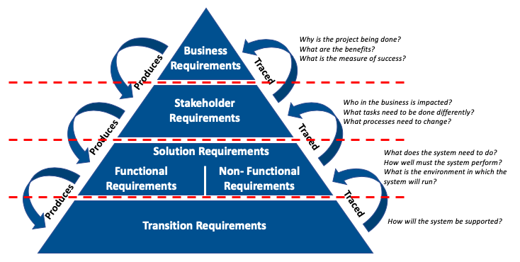

* 1. Intended audience

The audience for this document includes:

Table 1 - Audience

|  |  |
| --- | --- |
| Role | Stake |
|  |  |

* 1. Background and Business Context

*Describe the business environment and provide relevant information that sets the context for the proposed initiative, including what pre-work has been completed before arriving at this point.*

*e.g. Have there been previous attempts to address the problem? Was funding provided? What was the result? You could also briefly outline the steps taken to develop the Business Case, e.g. Who did you consult about it and what approvals or endorsements did they give for the contents?*

*You may wish to include a context diagram to help explain the current solution environment. These can be developed in Lucid Chart.*

*Type text here.*

Figure 1 - context diagram



* 1. Business Need

*Briefly provide a statement of business need that includes a brief description of the proposed project’s*

*purpose, goals and scope.*

* + 1. Problem analysis
    - Is the nature of the problem clear?

Cover the following areas below to the extent warranted by the proposed initiative:

* + - Restate the problem(s) and/or opportunities.
    - Specify the cause and effect of the problem, including any evidence such as case studies, demand forecasts or measures of current performance levels.
    - What business or service needs will be met by resolving this problem?
    - Specify the business impacts of the problem(s) and/or the potential impacts from failing to capitalise on the opportunity(ies).
    - Does the problem apply more broadly than to only one business unit, one division, or the department? If so, should there be a broad approach to resolving it?
    - Did you research and consult with others on the problem, both inside and outside the business unit?

Specify what your Business Case is setting out to achieve and what decision you are asking the decision-maker to make (e.g. approve the Business Case or commit funds for the next project phase).

.

The Investment Logic Map is a depiction of the agreed investment story (Investment Logic Map) on a single page. Investment Logic Mapping (ILM) is part of the Investment Management Standard developed by the Department of Treasury and Finance (Victoria, Australia).

* 1. Business Outcomes

*Provide details of the expected business outcomes of the initiative.*

*Note – This section requires input from the business stakeholders and should trace back to their strategic plan*

*A Business Outcome is the result of implementing a change. I.E. a productivity saving equal to 4 Full Time Employees (FTE). A Benefit is the value that outcome delivers, if management take advantage of that outcome. I.E. reducing head count by 4 FTE, or reassigning them to new work – and the value that new work will provide*

Table 2 - Business Outcomes

|  |  |
| --- | --- |
| Ref | Business Outcome Description |
| *BO1* | *Productivity saving of 4 FTE* |
| *BO2* |  |

* 1. Benefits

State the benefits believed to be achievable by solving the problem(s) and/or capitalising on the opportunity(ies). If possible, revisit the benefits outlined in the initial Concept/Project Brief. Address the following questions:

* What are the benefits, and will they help further the organisation’s strategic objectives?
* When and how will the proposed project report on the progress of benefits delivery (within a quarterly or annual report, for example). What are the roles in the benefit realisation process?
* Will the benefit KPIs provide reasonable evidence that the benefits have been delivered?
* Will you be able to demonstrate the return on the investment?
* Who is the person/group responsible for seeing that the benefits are realised (usually the business owner)?
  1. Strategic fit

*Show how the proposed investment is consistent with relevant legislation, regulations and policies, programs and projects, funding commitments and budgets, plans and strategies at the organisational level etc.*

* 1. Business Impact of Proposed Change

A detailed Change and Communication Plan Should be developed during the initiation phase.

Table 3 - Change Management

|  |  |
| --- | --- |
| **Internal** | **Expected Change Outcomes** |
| **People** | *Users* |
| **Process** | *Processes* |
| **System** | *Technology* |
| **Structure** | *i.e. Organisational changes* |
| **External** | **Expected Change Outcomes** |
| **People** | *Similar to internal but specifying any external impacts.* |
| **Process** |  |
| **System** |  |
| **Structure** |  |

1. Options Analysis

*Provide a summary of the different options considered, including recommendation of the preferred option.*

* 1. Options Evaluated

*Describe the method used for analysing and ranking the options and agreeing on the preferred option. Include the criteria used (e.g. financial, social, operational, legal, environmental and economic). Options may vary between approach options vs specific solution options depending on the stage of the initiative and the focus of the business case).*

*Compare the range of options you explored. At a minimum, provide at least three options, including an option to do nothing to quantify the dis-benefit of doing nothing (i.e. manage the problem using the existing approach/resources).*

*For each option, discuss the risks, timeframes, assumptions and feasibility in more detail.*

The following table provides a list of the options evaluated and the strengths and weaknesses of each option.

Table 4 - Options Evaluated

| **Option** | **Key Strengths** | **Key Weaknesses** | **Improvements against baseline** |
| --- | --- | --- | --- |
| 1. *Retain the current practices, processes, and systems.* | * *No process change is required* | * *Low end user productivity* * *Higher IT costs* | * *Financial:*   + *None* * *Non-financial:*    + *None* |
| 1. ***Move all Consultants to new X platform*** | * ***Increase in auto fulfilment for X transactions*** * ***Increased end user productivity*** * ***Reduced IT costs*** * ***Improved agility of IT systems*** | * ***Significant change program*** | * ***Financial:***    + ***$XXM per annum savings*** * ***Non financial:***   + ***Improved quality of financial management***   + ***Reduced client affecting errors***   + ***Reduced IT risk*** |
| 1. *Continue to use the current platform, but the finance function is centralised* | * *Improved oversight of financial transactions* | * *Extra handoff in the XX process* * *Low end user productivity* | * *Financial:*   + *$XM per annum savings* * *Non- financial:*   + *Improved quality of financial management* |
| 1. *X company use X system from receipt of initial request through to finalising the preferred option.* | * *X company end users retain the same user interface* * *Productivity improvements from auto fulfilment in X system stack* * *Improved oversight of financial transactions* | * *The interfacing between X system and back end system may be complex, expensive and prone to issues* * *Time taken to develop interfaces* * *Duplicated support costs* | * *Financial:*    + *$XM per annum savings* * *Non financial:*   + *Improved quality of financial management*   + *Reduced client affecting errors* |

* 1. Cash Flow or Cost Estimate

*Depending on the type of project, the project will either focus on profit (Cash Flow) or cost efficiencies (Cost Estimate).*

***If the Business Case is for a business need which will not directly increase financial profits, utilise the following approach.***

*Provide the basis of the total estimated costs for each option, such as benchmarking against similar projects, or based on specific information provided by vendors. Outline what you included and excluded, any contingencies built in, and any assumptions behind the estimates. Show the range of accuracy (e.g. +/- 10 per cent) against the estimates.*

*Complete a cost estimates table for each option. Include as many components as needed, e.g. design, project management costs, building, equipment or software development. Estimate the costs by year based on an anticipated start date out to 5 years (recommended for most IT implementations). Include any cost offsets (from revenue, for example) in brackets. Note any ongoing maintenance or other costs. Recommend forecast estimates should not exceed 5 years.*

Table 5 - Option X cost estimate SUMMARY

| **Component** | **20yy-yy**  **$** | **20yy-yy**  **$** | **20yy-yy**  **$** | **20yy-yy**  **$** | **20yy-yy**  **$** |
| --- | --- | --- | --- | --- | --- |
| *Component Name (e.g. solution design, project management etc)* |  |  |  |  |  |
|  |  |  |  |  |  |
| **Total** |  |  |  |  |  |

*Complete a table for each option*

***OR***

***If the Business Case is for a cash flow generating solution, utilise the following approach.***

*The Cash Flow chart below assesses the difference between the cash flow generated from the current state (do nothing option) and the preferred option. As can be seen, the preferred option begins to provide a greater cash flow to the business within 3 years of implementation. This trajectory increases to over a 100% improvement by year 5.*

Figure 2 - Option X cashflow comparison

* + 1. Costs vs Benefits

***Not required for projects requiring Cost Estimates only.***

*Be sure to provide visual aids to further explain the reasoning for the preferred option.*

*I.E. The Cost/Benefit chart below assesses the difference between the costs incurred by option x, and the benefits that can be derived from Option X. As shown in the chart, the costs will outweigh the benefits for the first 2 years. From that point onwards however, there is a significant increase in benefits to be realised culminating in a 4 fold improvement by end of year 5.*

Figure 3 - OPTION X CASHFLOW Benefit

* + 1. Payback Period

***Not required for projects requiring Cost Estimates only.***

*I.E. The Cumulative Cash flow diagram below indicates the point at which Option X will pay back the invested amount, and the trajectory from that point. As you can see …..*

Figure 4 - Cumulative Cash flow

* 1. Assumptions

*Clearly detail all assumptions made in the development of this document*

*e.g. It is assumed that ABC will continue to be the external provider of service XYZ.*

The following Assumptions have been identified:

* Assumption # 1
* Assumption # 2
* Assumption # 3
  1. Constraints

*List the factors that have been identified which will either constrain the proposed solution, or have constrained the:*

* *Deadlines (e.g. solution must be delivered by [date])*
* *Budget (e.g. budget limit of [$x] over [number] years)*
* *Staff and contracting resources (e.g. [resource x] will/will not be available) and supplier availability*
* *Any organisational change required*
* *Any uncertainties or regulatory, legislative or policy changes affecting the proposal*
* *Tolerances (i.e. level of variation permitted for schedule, scope, quality and budget)*
* *Method (e.g. the procurement approach, if any, limits on out-sourcing, restrictions on software licensing etc.).*

The following constraints have been identified:

Table 6 – constraints

| **Constraint Name** | **Description** | **Constraint Type** | **Constraint Handler** |
| --- | --- | --- | --- |
| *List the constraint name* | *Add a brief description of the constraint* | *Indicate the constraint type as in for e.g. Regulatory, Statutory, Data Privacy, Code of Conduct etc.* | *Mention the required action; e.g. Abide with the constraint, provide solution, work around etc.* |
|  |  |  |  |

* 1. **Dependencies**

*List the requirement/initiative dependencies that have been identified. These could be dependencies on other projects, resources, people or business areas/functions.*

The following dependencies have been identified:

Table 7 - Dependencies

| **Dependency** | **Description** | **Dependency Type** | **Coordination Approach** |
| --- | --- | --- | --- |
| *List the dependency name* | *Add a brief description of the dependency* | *Is the requirement/initiative dependent on other projects/ resources/ business functions?*  *OR*  *Are they dependent on us?*  *Or*  *Both?* | *What measures are in place to manage the dependency?* |
|  |  |  |  |

* 1. **Risks and Issues**

*List any risks / issues that have been identified for the proposed initiative. Include high-level risks and issues (e.g. that may impact a large section of the organisation), rather than smaller day-to-day ones (e.g. individual requirement-related). All project level risks & issues will be managed separately as part of the project risk register, by the Project Manager.*

The following risks/issues have been identified and will need to be managed to ensure the proposed initiative requirements are successfully delivered:

Table 8 – RISKS AND ISSUES

| **Risk / Issue** | **Potential Impact** | **Potential Solution** |
| --- | --- | --- |
| *List the risk/issue name* | *What is the likelihood it will occur? If it does occur, how significant is the impact?* | *What mitigation approach will be used to manage the risk/issue?* |
|  |  |  |

1. Recommendation
   1. Recommended Option

*Identify the preferred option and the reasons why this was selected.*

*Example: Project Option 2 – Fully integrated Enterprise Resource Planning solution and Remediation of current solutions implemented over five years.*

*This option best delvers on the expected benefits by addressing the existing business critical risks to rostering and payroll, whilst progressing the strategic enterprise resource planning solution with full functionality to optimise operational efficiency and enable real time visibility of incidents.*

* 1. Project Scope
     1. Inclusions

*Describe the intended scope of the project or initiative. Scope can be defined as e.g. Zachmann - who, what, where, when. Can include comments about systems, processes, regions/geographies and teams.*

The following Inclusions have been identified:

* Inclusion # 1 e.g. upgrade existing system
* Inclusion # 2
* Inclusion # 3
  + 1. Exclusions

*Detail what is not in scope and what opportunities have been intentionally not pursued for this project or initiative.*

Exclusion are specified as follows:

* Exclusion # 1 e.g. new technology will not be purchased
* Exclusion # 2
* Exclusion # 3
  1. Costs

***For projects requiring Cost Estimates only:***

*Re-use the summary you completed in section 2.2.*

Table 9 - RECOMMENDED OPTION DETAILED COST ESTIMATE

| **Component** | **20yy-yy**  **$** | **20yy-yy**  **$** | **20yy-yy**  **$** |
| --- | --- | --- | --- |
| *Component* |  |  |  |
|  |  |  |  |
| **Total** |  |  |  |

***OR***

***For projects requiring cash flow generating solution:***

*Provide a summary of the total cost of the initiative (Recommended option only. You can refer to the detailed financial analysis spreadsheet. Include in Appendix C.*

* 1. Business Impact of Proposed Change

A detailed Change and Communication Plan Should be developed during the initiation phase.

Table 3 - Change Management

|  |  |
| --- | --- |
| **Internal** | **Expected Change Outcomes** |
| **People** | *Users* |
| **Process** | *Processes* |
| **System** | *Technology* |
| **Structure** | *i.e. Organisational changes* |
| **External** | **Expected Change Outcomes** |
| **People** | *Similar to internal but specifying any external impacts.* |
| **Process** |  |
| **System** |  |
| **Structure** |  |

* 1. Expected Benefits

*Provide details of the expected benefits the initiative will deliver, based on the* *recommended option. These must be expressed in measurable terms against today’s situation. Benefits may include:*

*Direct Financial Benefit*

* + *Additional revenue generated as a result of the project*
  + *Direct Cost savings as a result of the project*

*Indirect Financial Benefit*

* + *This may be opportunity benefits that could be linked to the improvement*

*Non-Financial Benefit*

* + *Social*
  + *Economic*
  + *Environmental*

*The Primary Benefits are those that have been identified as the drivers behind the Business Case and are aligned to the Corporate Strategy.*

The Primary Benefits of this initiative are tabled below.

Table 10 – primary benefits

|  |  |
| --- | --- |
| Benefit ID | Title/Description |
| *BB* | ***Title***  *Description* |

* + 1. Financial Benefit

The targeted financial benefits are depicted in the table below. (See Annex X for details of the benefit)

Table 11 – financial benefits

|  |  |  |  |  |  |  |
| --- | --- | --- | --- | --- | --- | --- |
| Benefit ID | Title | Current Cost per Year | Target Reduction in Cost | Once_Off | Annual Benefit | Total 5 year saving |
|  |  |  |  |  |  |  |

* + 1. Non-Financial Benefit

The targeted non-financial benefits are depicted in the table below. (See Annex X for details of the benefit)

Table 12 – non-financial benefits

|  |  |  |  |  |
| --- | --- | --- | --- | --- |
| Benefit ID | Title | Current | Improvement | Future Estimate |
|  |  | *y%* | *y%* | *y%* |

* 1. Proposed delivery method

Describe how the project will be implemented, e.g. by closed or open tender for particular services or assets, and who will implement it.

* 1. Stakeholder identification and engagement

Highlight here the key stakeholders or stakeholder groups for the initial Business Case and those with a role or interest in the proposed project.

* 1. Governance

Provide a high-level governance structure for the project to deliver the recommended option, showing the decision-maker(s), the Senior Responsible Owner, the key stakeholder representatives, the project organisation, and project assurance etc.

* 1. Assumptions

*Clearly detail all assumptions in relation to the proposed implementation of the recommended option.*

*For example – It is assumed that ABC will continue to be the external provider of service XYZ.*

The following Assumptions have been identified:

Table 13 - recommended option assumptions

| **Id** | **Description** | **Effect on Proposed Project Investment** |
| --- | --- | --- |
| *List the constraint name* | *Add a brief description of the constraint* | *Indicate the constraint type.* |
|  |  |  |
|  |  |  |

* 1. Constraints

*List the constraints that have been identified for the recommended option.*

The following constraints have been identified:

Table 14 – recommended option constraints

| **Constraint Name** | **Description** | **Constraint Type** | **Constraint Handler** |
| --- | --- | --- | --- |
| *List the constraint name* | *Add a brief description of the constraint* | *Indicate the constraint type.* | *Mention the required action.* |
|  |  |  |  |
|  |  |  |  |

* 1. Dependencies

*List the Requirement dependencies that have been identified. These could be dependencies on other projects, resources, people or business areas/functions.*

The following dependencies have been identified:

Table 15 - recommended option Dependencies

| **Dependency** | **Description** | **Dependency Type** | **Coordination Approach** |
| --- | --- | --- | --- |
| *List the dependency name* | *Add a brief description of the dependency* | *Are we dependent on other projects/ resources/ business functions?*  *OR*  *Are they dependent on this poject?*  *Or*  *Both?* | *What measures are in place to manage the dependency?* |
|  |  |  |  |
|  |  |  |  |

* 1. Project Timeframe

*Provide a high-level project timeframe for the recommended option only. Specify the basis and assumptions you used in setting the timelines and whether the date per deliverable/milestone is:*

*An absolute date, or*

*Dependent upon an internal project deliverable (e.g. project commencement)*

*Dependent upon an external milestone or event (e.g. external software commissioning, hold point)*

Table 16 - Timeframe

|  |  |
| --- | --- |
| Estimated Date | Milestones and/or Deliverables |
|  |  |
|  |  |
|  |  |

* 1. Investment Appraisal

*Provide a summary of the investment appraisal including funding source (if available) for the initiative (recommended option only). The detailed financial analysis included in Appendix C can be referenced for more detail.*

* 1. References and Related Documents

*List any documents that support this Business Case, including pre-project documents like concept briefs, feasibility analysis, the project plan, the benefits plan, strategy documents, change control, risks and issues (including the risk register), stakeholder matrices, communications plans, requirements management plans, quality assurance.*

Table of references and related documents used within this document are contained in the following table.

Table 17 - References

|  |  |  |
| --- | --- | --- |
| Document Type | Document Name | Location |
| *Concept Brief* |  | *Link here* |

* 1. Definitions, Acronyms and Abbreviations

Table of terms and associated descriptions used within this document are contained in the following table.

Table 18 - Acronyms

|  |  |
| --- | --- |
| Acronym | Definition |
|  |  |

Table 19 - Terminology

|  |  |
| --- | --- |
| Terminology | Definition |
| *Business Case Initiative* | *The project to deliver the recommendation of the business case and the operation of the resulting outputs of the project over its lifetime.* |

Appendix A – Investment Logic Map

*Investment Logic Mapping (ILM) is a technique to ensure that robust discussion and thinking is done up-front, resulting in a sound problem definition, before solutions are identified and before any investment decision is made.*

*It is a technique to ensure the 'story' about any proposed investment makes sense (the 'logic' part of ILM) and to test and confirm that the rationale for a proposed investment is evidence-based and sufficiently compelling to convince decision makers to commit to invest in further investigation and planning.*

*The Investment Logic Map is a simple single-page flowchart that tells the story of an investment and exposes its underpinning logic. It is in plain English and has been designed to answer many of the key questions required to make an investment decision.*

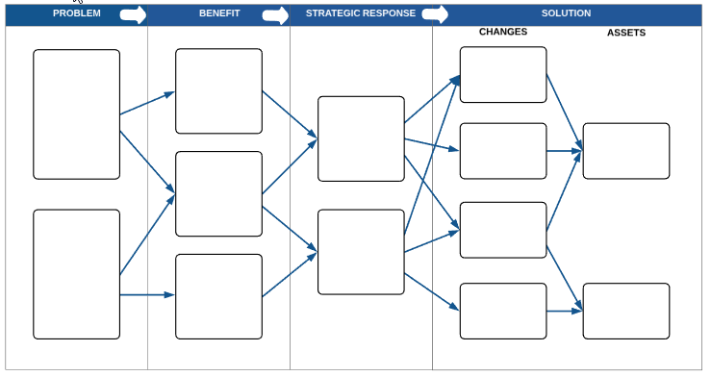

Appendix B – Benefits Dependency Map

*The diagram below is an example of a benefits dependency map. This was created using the template Lucid Chart. You may wish to make this page landscape. A benefits dependency map can be used to show the link between your project or programme and the business or organisation’s strategic objectives.*

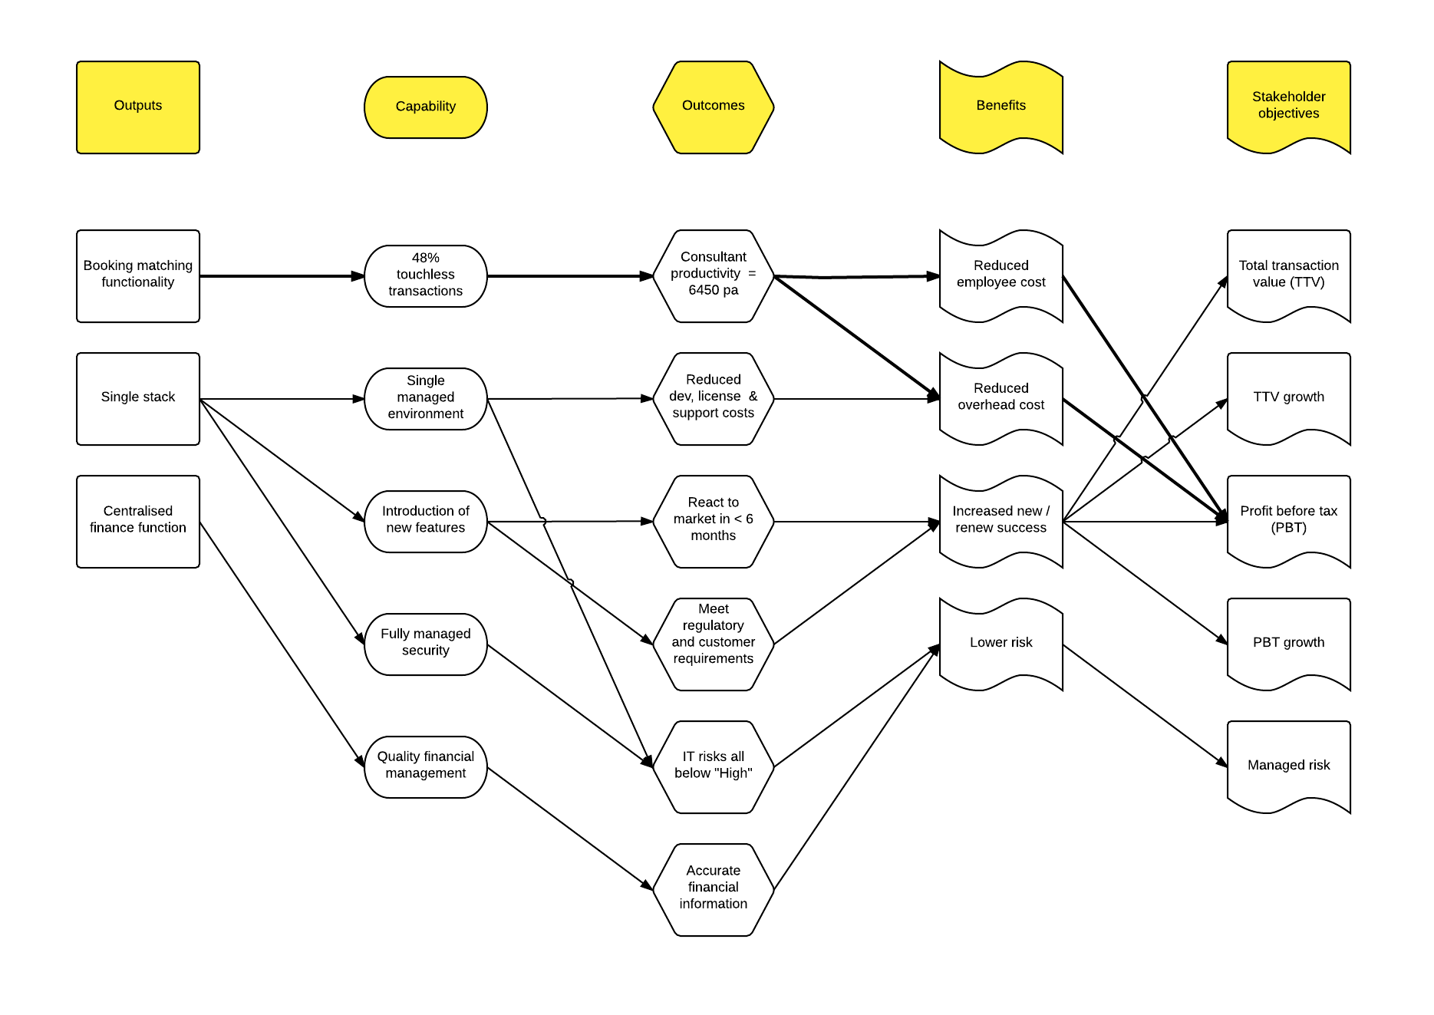

Appendix C - Financial Analysis

*Each option being considered in the business case requires a detailed financial analysis to be conducted including project costs, Return On Investment and payback period.*

Financial Analysis –Recommended Option *Option x – Option Short Description*

*Financial Summary included here*

Financial Analysis: “Business Case Financial (Net Cash Flow)” for *Option X to be linked*. *This can be cut and paste from Excel Financials sheet (Paste as PNG)*

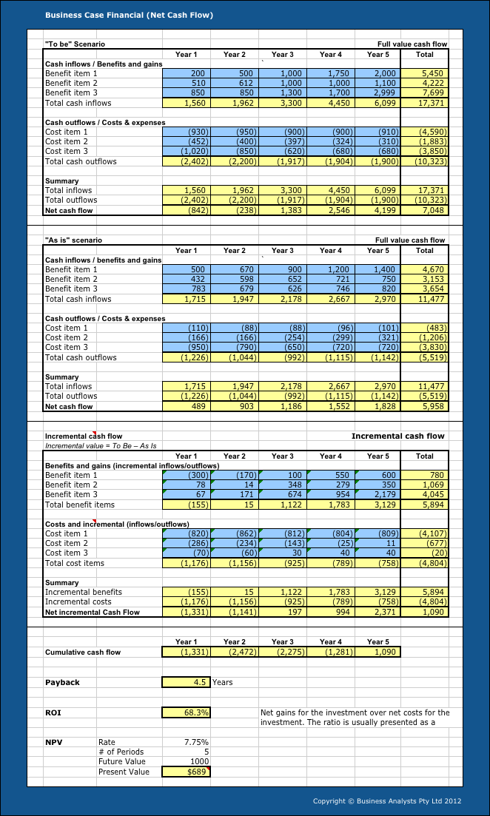

Financial Analysis – Option 2 *Option x – Option Short Description*

*Financial Summary included here*

Financial Analysis: “Business Case Financial (Net Cash Flow)” for *Option X to be linked*. *This can be cut and paste from Excel Financials sheet (Paste as PNG)*

Financial Analysis – Option 3 *Option x – Option Short Description*

*Financial Summary included here*

Financial Analysis: “Business Case Financial (Net Cash Flow)” for *Option X to be linked*. *This can be cut and paste from Excel Financials sheet (Paste as PNG)*

Appendix D– *Additional References*

*Add additional Appendices as required.*