Improve | Innovate | Digitise

Requirements Quality Assurance Checklist
<<Project Name>>
Status Draft / Issued
Monday, 2 March 2020
Business Analysis (BAPL)
Improve | Innovate | Digitise

“Organizations surveyed waste over one in three dollars spent in IT development and implementation annually as a result of poor requirements maturity.”
75%

Keith Ellis, Business Analysis Benchmark—The Path to Success, IAG Consulting
47%
“Unsuccessful projects fail to meet goals due to poor requirements”

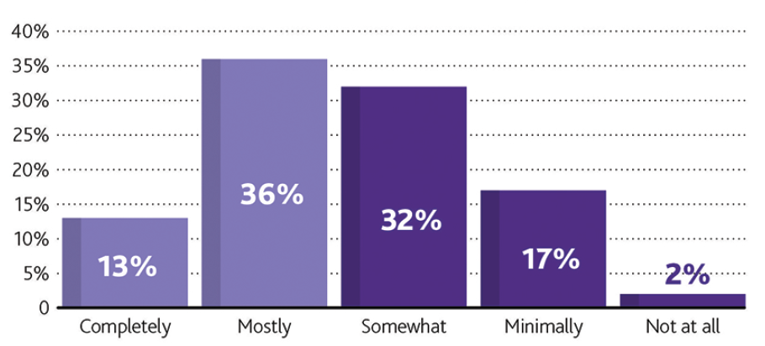
49%
“Less than half of organizations have the necessary resources in place to properly perform business analysis and requirements management
87%
“of organizations recognize that improvements in their performance of requirements are needed”

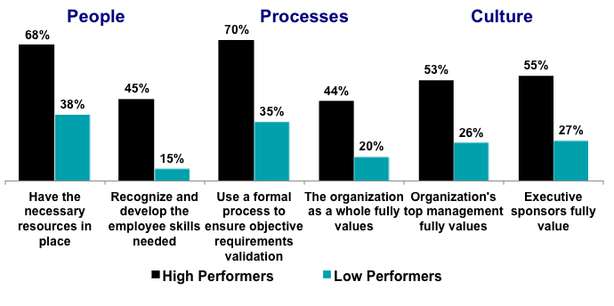
70%
“of High Performing organizations use a formal process to ensure objective requirements validation”
Project Management Institute International
Background:

Poor requirements have been repeatedly identified as one of the major root cause for project failures. Fixing requirements gaps after a solution release has always been costly.
- For over a decade Business Analysts Pty Ltd (BAPL) has provided its world-leading business analysis expertise across the corporate, government and not-for-profit sectors.
- In the delivery of our services, we have set the benchmark for a truly independent and disciplined approach to introducing and managing quality requirements. Our clients have all significantly benefited from using this Requirements Quality Assurance Checklist.

Value:

The intent of this checklist is to provide a quick health check on the quality of the requirements:
- It will assist you, in determining whether the requirements are documented according to international standards, thus highlighting requirements gaps early.
- It will assist you, in picking up mistakes early, thus reduce negative impacts (rework) on development, testing and outcomes.
- It will assist you, in determining whether the requirements are traceable, thus ensuring each requirement is valid and relevant, preventing an overbuild/costly solution.

Note:

- This checklist is based on international Business Analysis and Quality Standards:
- IIBA® - BABOK©,
- PMI® - BA Practitioners Guide©
- ISO®/IEC CD 25010: Software engineering – Software product Quality Requirements and Evaluation (SQuaRE)
- V-Model (Software Development)
- TOGAF® Architecture Development Method (ADM) ©
- It’s highly recommended to fill in the "Comments” column, especially for the assurance questions that has been identified as “N/A”.
- This checklist can be used during a requirements management life cycle, or post project/program for lessons learned purposes.
- This checklist can be used by both Waterfall or in Agile, project delivery methodology as documentation to support requirements re-use should be developed using either approach.

1) Business Requirements | Yes | No | N/A | Comments
Do the business requirements explain the (WHY) rather than the solution?
Are the Business Requirements traced to Benefits?
Have requirements been identified in accordance with a unique requirement identifier?
Are the requirements/benefits verifiable? (i.e. They do not include words that have relative meaning, and as a result are not verifiable (e.g. easy, maximum, minimum, more efficient, adequate)
Are the Business Requirements aligned with the organisations' architecture scope and Architecture Requirements Management process (TOGAF)?
Are requirements clear and unambiguous?
Are all requirements independent of each other?
2) Stakeholder Requirements | Yes | No | N/A | Comments
Are all the User Requirements / Stakeholder Requirements traced to Business Requirements?
Business Processes - Has each process been traced back to the business process framework or value chain?
Have requirements been identified in accordance with a unique requirement identifier?
Business Processes - Can each process related requirement be traced to a process task, and does every process task have traceability to a requirement?
Business Processes - Are all diagrams clear and understandable?
Are the Business Processes documented using international standard notations (BPMN/EPC)?
3.1) Solution Requirements - FUNCTIONAL: | Yes | No | N/A | Comments
Are all the Functional – (Presentation, Logical, and Data) Tier Requirements traced to Stakeholder Requirements?
Graphical User Interface (GUI) - Have all the user interfaces necessary to meet the required information and functional requirements specified?
Have requirements been identified in accordance with a unique requirement identifier?
Reports - Have all required reports been specified in terms of which entities are required and which attributes of the entities are required?
Reports - Are the reports at a requirements level (as opposed to a design level) with only the information requirements presented?
Has a class or entity diagram been created?
Have DATA FLOW DIAGRAMS (DFD) been used?
Has the data cleansing, conversion and migration requirements been clearly defined or has a reference been made to an alternate requirements specification?
Data Characteristics and Categorization documented? (Static Data, Dynamic Input Data, Dynamic Output Data, Internally Generated Data)
Data Constraints, Retention and Storage requirements documented?
Frequency of Data update and processing documented?
Data Handling requirements are documented? Source of Input, Medium and Device, Input Medium and Device, Output Medium and Device, Recipients, Data Collection Procedures, User Access, Error Handling, Data Responsibilities, Security)
3.2) Solution Requirements  – NON- FUNCTIONAL: | Yes | No | N/A | Comments
Are all the Non Functional Requirements traced to User/Stakeholder Requirements?
Have Availability requirements been captured?
Have Compatibility requirements been captured?
Have Functionality requirements been captured? |  |  |  | *
Have Maintainability requirements been captured?
Have Performance Efficiency requirements been captured?
Have Portability requirements been captured?
Have Reliability requirements been captured? |  |  |  | *
Have Scalability requirements been captured? |  |  |  | *
Have Security requirements been captured? |  |  |  | *
Have Usability requirements been captured? |  |  |  | *
Have Certification requirements been captured? |  |  |  | *
Have Compliance requirements been captured? |  |  |  | *
Have Localisation requirements been captured? |  |  |  | *
Have Service Level Agreements been captured? |  |  |  | *
Have Extensibility requirements been captured? |  |  |  | *

4) Transition Requirements | Yes | No | N/A | Comments
Change - Are Change Categorization and Prioritization Rules, Configuration Management Plan, Integrated Change Calendar, Change Management System and Change Advisory Board noted or specified?
Operate - Are Security Audit, Data Backup and Recovery Strategy, Documentation Backup and Recovery Strategy, Configuration Status Accounting and Audit, Disaster Recovery (DR) Planning, Security Administration noted or specified?
Support - Are Problem Prioritization Rules, Incident Correlation and Trend Analysis, Capacity, Performance, and Business Metrics Reporting, Incident Database noted or specified?
Optimize - Are Capacity and Performance Modelling and SLA Reviews noted or specified?
5) Requirements Document | Yes | No | N/A | Comments
Template – Correct template for the document been used?
Document Format Requirements – Pages numbered, structured, organised, unnecessary spaces removed?
Appendices - Has each appendix been uniquely identified using an alphabetic character?
Language and Style - Is the document understandable on first reading without the need for clarification from the document author/editor?
6) Requirements Measurement | Yes | No | N/A | Comments
Atomic
Complete
Consistent
Concise (short, sharp)
Feasible (Realistic, Possible)
Unambiguous
Testable
Prioritised
Understandable

Document details
Overall Comments
Reviewer Name:

Project Information
Organisation | <<Organisation Name>>
Project Sponsor | <<Sponsor Name>>
Project Name | <<Project Name>>
Project Number | <<Project ID>>

Reviewer and Approval
The content of this document is hereby agreed to and approved by:
Name | Position | Signature | Date

Contact for enquiries
If you have any questions regarding the information in this document, please forward details to following contact point:

Business Analysis (BAPL)
Email: info@business-analysis.com.au
Website: www.business-analysis.com.com
Phone: 1300 33 11 64

Copyright © Business Analysts Pty Ltd 2012
Copyright protects this publication. Except for purposes permitted by the Copyright Act, reproduction by whatever means is prohibited without the prior written permission of Business Analysis (BAPL). Inquiries should be addressed info@business-analysis.com.au

Disclaimer
Business Analysis (BAPL) does not guarantee or warrants the results obtained while using this document and conducting business analysis activities. Usage of this document is strictly under the proviso that the user takes all responsibility for the document outcomes.

