Improve | Innovate | Digitise

Internal and External Assessment

<<Initiative/Project Name>>

Status Draft / Issued

Monday, 2 March 2020

Business Analysis (BAPL)

Status: [Draft / Issued]

Document Controls

**Project Information**

|  |  |
| --- | --- |
| Organisation | << Organisation Name >> |
| **Project Sponsor** | << Project Sponsor >> |
| **Project Name** | <<Project Name>> |
| **Project Number** | << Project ID >> |

**Contact for Enquiries and Proposed Changes**

If you have any questions regarding the information in this document, or suggestions for improving the document, please forward details to Business Analysis (BAPL) at the following contact point:

Email: [info@business-analysis.com.au](mailto:info@business-analysis.com.au)

Website: [www.business-analysis.com.au](http://www.business-analysis.com.au)

Phone: 1300 33 11 64

**Version History**

|  |  |  |  |
| --- | --- | --- | --- |
| Version | Date | Changed By | Nature of Amendment |
|  |  |  |  |
|  |  |  |  |

**Document Approval**

The content of this document is hereby agreed to by:

|  |  |
| --- | --- |
| Name | Position |
|  |  |

**Stakeholder Review**

The content of this document has been reviewed by:

| **Name & Role** | **Title/Designation** | **Approval Signature** | **Date** |
| --- | --- | --- | --- |
|  |  |  |  |
|  |  |  |  |
|  |  |  |  |

**Copyright © Business Analysts Pty Ltd 2012**

Copyright © Business Analysts Pty Ltd 2012. Copyright protects this publication. Except for purposes permitted by the Copyright Act, reproduction by whatever means is prohibited without the prior registration and written permission of Business Analysts Pty Ltd. Inquiries should be addressed to [info@business-analysis.com.au](mailto:info@business-analysis.com.au). Do not remove this copyright statement.

Copyright © This document has been licensed to <<Organisation Name>>. It must not be copied or reproduced in any way whatsoever outside of <<Organisation Name>> without the authority of Business Analysts Pty Ltd. This document is uncontrolled when printed. An electronic database manages and stores the controlled version.

**Disclaimer**

Business Analysis (BAPL) does not guarantee or warrants the results obtained while using this document and conducting business analysis activities. Usage of this document is strictly under the proviso that the user takes all responsibility for the document outcomes.

Table of Contents

1. Executive Summary 1

2. Introduction 3

2.1. Purpose 3

2.2. Background 3

2.3. Study Approach 3

3. Market Study Scope 4

3.1 In Scope 4

3.2 Out of Scope 4

4. Internal/External Outlook 5

4.1. Industrial Trend- PESTEL Framework 5

4.1.1. Market Situation Insight 6

4.2. Competitive Landscape - Competitive Rivalry- 5 Force, (BCG matrix) 7

4.3. Competitive Advantage - SWOT Analysis 8

4.4. Perceptual Map 8

4.5. Pricing & Forecasting 9

5. Organisation Internal Resources- APQC Capability Model 10

5.1.1. Investigation of Available Tools in the Market 12

Appendix A – People Consulted 13

Table of Figures

Figure 1- APQC Capability Model 10

Figure 4 – Market Potential 2

Table of Tables

Table 1 - Acronyms 2

Table 2 - Glossary 2

Table 3 - References 2

Table 4 – PESTEL Framework 5

Table 5 – Competitive Rivalry 7

Table 6 – SWOT Analysis 8

Table 7 – APQC Capability Model 1

Table 8 - People Consulted 3

***Template Usage Guidelines***

***The text mentioned below is to be used as a reference guide while completing this document. Remove this section/page after completing/before-publishing this document.***

1. *The dark blue text represents help/instructional text in the template – please remove it from the final version and/or before publishing the document.*
2. *This template is designed to capture Feasibility Study information only. Detailed functional and non-functional requirements should be captured in the BAPL Functional Requirements Specification template.*
3. *Please do not remove any section(s) from this document unless otherwise specified.*
4. *Please do not leave any section blank.*
5. *Please ensure not to describe any System Design element(s) in this document.*
6. *Do not forget to update the table of contents figures and caption tables (Reference tab in MSWord) once the document is complete.*
7. *Introduce naming conventions as required for traceability purposes.*
8. Executive Summary

*The executive summary provides an overview of the content contained in the market study document. The executive summary should not say anything that has not been included in the body of the template. Items that typically need to be in this summary include:*

* *A brief description of the problem or opportunity to be addressed*
* *An outline of the scope*
* *An overview of the project objectives and benefits sought*
* *Key risks and issues*
* *A summary of the time, costs and resources to complete the next stage*
* *A summary of the recommended course of action.*

Acronyms and Glossary

The following Acronyms are used throughout this report.

Table 1 - Acronyms

|  |  |
| --- | --- |
| Acronym | Meaning |
|  |  |
|  |  |
|  |  |

The following terminology is used throughout this report.

Table 2 - Glossary

|  |  |  |
| --- | --- | --- |
| Term | Description | Source |
|  |  |  |
|  |  |  |
|  |  |  |

References

The following reference material was used in compiling this feasibility study.

Table 3 - References

|  |  |  |
| --- | --- | --- |
| Id | Description | Reference |
|  |  |  |
|  |  |  |
|  |  |  |

1. Introduction
   1. Purpose

*Describe the purpose of this document within the context of the project or change.*

*For example, the purpose of this document is to identify, explore and evaluate the current internal and external conditions that should be considered when defining a new or improved product for market consumption.*

The purpose of this document is to

* 1. Background

*Provide a description and information about why the research needs to be done. State the Business need/problem explicitly, and what this study will achieve?*

*For example, the background of this study is to assess the feasibility to promote the products/services via the internet and increase online sales by encouraging customers to visit the website and make online bargains.*

* 1. Study Approach

This section notes the approach(s) taken to gather information during the initial market analysis of other businesses to solve or address a business problem or business opportunity. Most companies use one or more of five basic methods: surveys, focus groups, personal interviews, observation, and field trials. The type of information needed and budget will determine which techniques you choose.

In order to assess the feasibility, the following approaches were taken:

* Approach # 1
* Approach # 2
* Approach # 3

1. Market Study Scope

3.1 In Scope

*Detail what is in scope and what opportunities will be pursued for this project or initiative.*

The following items are within the scope of this study:

* *Inclusion # 1*
* *Inclusion # 2*
* *Inclusion # 3*

3.2 Out of Scope

*Detail what is not in scope and what opportunities have been intentionally not pursued for this project or initiative.*

The following items are not within the scope of this study:

* *Exclusion # 1*
* *Exclusion # 2*
* *Exclusion # 3*

1. Market and Internal Assessment

Identify the key competitors and their market positioning. Inclusive of the size of key competitors in units/dollars, brief market shares, sales trends of key competitors, perceived marketing strategies of key competitors and their probable impact on the company.

* 1. Industrial Trend- PESTEL Framework

PESTEL analysis is a framework used to analyse the external marketing environment factors that may have an impact on your organisation. The completed PESTEL analysis can be used to help identify the strengths and weaknesses for a [SWOT analysis](https://www.professionalacademy.com/news/marketing-theories-swot-analysis).

Table 4 – PESTEL Framework

| **Factors** | **Description** | **Compliance** |
| --- | --- | --- |
| Political  *Includes to what degree a government intervenes in the economy. Inclusive of government policy, foreign trade policy, tax policy, labour law, environmental law, and trade restrictions.* | *Add a brief description of the factors* | *Comparing the factors to client’s current practice* |
| *Economic*  *Includes – economic growth, interest rates, inflation, and disposable income of consumers and companies. These can be broken down into macro-economic factors and micro-economic factors.* |  |  |
| Social  *Involves the shared belief and attitudes of the population. Includes – population growth, age distribution, health consciousness, and career attitudes, which help us to understand customers and what drives them.* |  |  |
| Technological   * *Includes new ways of producing and* * *distributing goods, products and services* * *. It also includes new ways of communicating with the market.* |  |  |
| Environmental  *For example, doing business as an ethical and sustainable company, carbon footprint targets set by governments.* |  |  |
| Legal  *Includes, health and safety, equal opportunities, advertising standards, consumer rights, product labelling and product safety.* |  |  |

* + 1. Market Situation Insight

*What are other market factors, practices or specific marketing actions that affect the market? Summarise the key insights from the industry trend phenomenon and, reflect as industry trends.*

*For example:*

* *The beer campaign will start cooking on major advertising channels for the upcoming summer and holiday season starting from November. The market will become more competitive than usual.*
* *Under holiday seasons or some particular event, incidents that will affect the market need/ reaction.*
* *The bush fire has indirectly increased the awareness of a reliable insurance company.*
* *Online sales are expected to grow at a rapid rate, becoming a significant source of revenue. However, the data privacy issue is a potential threat if we don’t have a complete solution.*
  1. Competitive Landscape - Competitive Rivalry- 5 Force, (BCG matrix)

The competitive rivalry provides an overview of how our company sits within the industry and the market saturation.

Table 5 – Competitive Rivalry

| **Constraint Name** | **Description** | **Compliance** |
| --- | --- | --- |
| The threat of the new entrants | Warning*High and Steady* | *New entrants lack the customer base that established industry players have built up.* |
| Bargaining power of suppliers |  |  |
| Bargaining power of buyers |  |  |
| Threat of substitutes |  |  |
| Competitive rivalry |  |  |

* 1. Competitive Advantage - SWOT Analysis

*A SWOT analysis is a technique used to determine and define your Strengths, Weaknesses, Opportunities, and Threats. SWOT analyses can be applied to the entire organisation or individual projects within a single department. Most commonly, SWOT analyses are used at the organisational level to determine how closely a business is aligned with its growth trajectories and success benchmarks. Still, they can also be used to ascertain how well a particular project – such as* [*an online advertising campaign*](https://www.wordstream.com/blog/ws/2017/07/05/online-advertising-costs)*– is performing according to initial projections.*

Table 6 – SWOT Analysis

|  | Internal Strengths   * *Things your company does well* * *Qualities that separate you from your competitors* * *Internal resources such as skilled, knowledgeable staff Tangible assets such as intellectual property, capital, and proprietary technologies.* | Internal Weakness   * *Things your company lacks* * *Things your competitors do better than you* * *Resource limitations*   *Unclear unique selling proposition* |
| --- | --- | --- |
| **Opportunities**  (External, Helpful)   * *Underserved markets for specific products* * *Few competitors in your area* * *The emerging need for your products or services*   *Press/media coverage of your company.* | *Add a brief description:*   * *For example - Ability to effectively manage risk* | *Add a brief description:*   * *For example - How the company current positioning and compliance* |
| **Threats**  (External, Harmful)   * *Emerging competitors* * *Changing regulatory environment* * *Negative press/media coverage*   *Changing customer attitudes toward your company* | *Add a brief description:*   * *For example,* | *Add a brief description:*   * *For example,* |

* 1. Perceptual Map

*A perceptual map is a visual representation of the perceptions of customers or potential customers about specific attributes of your organization, brand, product, service, or idea.*

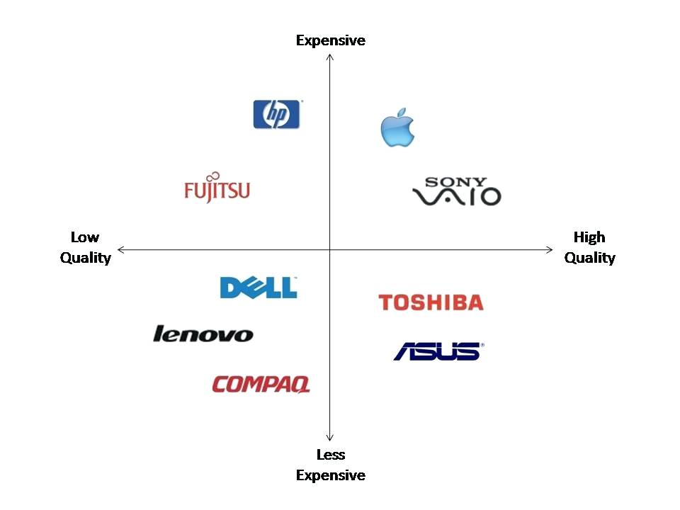

* 1. Pricing & Forecasting

*A statistic review of the product or service cost structure, past performance or industry revenue pattern to identify a potential trend of the product or service.*

1. Organisation Internal Resources - APQC overview Model

This section presents the business context, business process and business requirements that the solution needs to address.

The Process Classification Framework (PCF) is a hierarchical list of business processes which can be used to identify value chains as well as improvement opportunities to possibly standardise processes within an organisation. The hierarchical levels are broken down from a top-level view (category) to gradually more granular levels (process group, to process, to activity, and lasting to task level).

Figure 1- APQC FRAMEWORK

*The following table captures the components that make-up the current internal process landscape. This includes existing processes, process owners, and the IT solutions supporting those processes. These considerations will be used as input when assessing a viable idea to address the business need.*

Table 7 – APQC Process assessment

| **Function** | **Process Group** | **Process** | **Process Owner** | **Information  & Systems** |
| --- | --- | --- | --- | --- |
| *1.0 Develop Vision and Strategy* | *Process group name – i.e. Deliver Service to Customer* | *Process name and high-level purpose.* | *Role/Title* | *This input incorporates systems, information, software and data that are used as the basis of decision making to be effective.* |
| *2.0 Develop and Manage Products and Services* |  |  |  |  |
| *3.0 Market and Sell Products and Services* |  |  |  |  |
| *4.0 Deliver Products and Services* |  |  |  |  |
| *5.0 Manage Customer Service* |  |  |  |  |
| *6.0 Develop and Manage Human Capital* |  |  |  |  |
| *7.0 Manage Information Technology* |  |  |  |  |
| *8.0 Manage Financial Resources* |  |  |  |  |
| *9.0 Acquire, Construct, and Manage Assets* |  |  |  |  |
| *10.0 Manage Enterprise Risk, Compliance, Remediation, and Remediation* |  |  |  |  |
| *11.0 Manage External Relations* |  |  |  |  |
| *12.0 Develop and Manage Business Capabilities* |  |  |  |  |

* + 1. Investigation of Available Tools in the Market

This section summarises the results of the investigation performed on available tools within the market. The investigation was time-boxed to fit within the timeframes of the Market Study.

*List the investigation of available tools in the market, and the methods used for investigating those tools.*

*Some examples of effective investigative techniques are:*

* *Internet research on tools available in the market*
* *Surveys (capturing needs, values, attitudes, behaviours and demographics) – these can include, in-person, telephone, mail and, online surveys.*
* *Focus groups and personal interviews*
* *Observation*
* *Field trials or product testing of existing and emerging tools*
* *Vendor demonstrations*
* *Discussions with Stakeholders on available tools*
* *Pricing research*

Appendix A – People Consulted

The following table is a list of the people consulted and interviewed during the market scan.

Table 8 - People Consulted

|  |  |  |  |
| --- | --- | --- | --- |
| Name | Position / Title | Department / Company | Contribution / Reason for Contact |
|  |  |  |  |
|  |  |  |  |